EBU6304 Software Engineering Group Project

2025-26
Group number | 46
member 1 | QM no: 231222877 | Name: Tian Xihe
member 2 | QM no: 231221434 | Name: Wang Yixiang
member 3 | QM no: 231222040 | Name: Song Hanlin
member 4 | QM no: 231220530 | Name: Ran Bingkun
member 5 | QM no: 231221010 | Name: Ang Boyu
member 6 | QM no: 231222291 | Name: Wu Yanze

First report

Requirements
1.1 Fact-Finding Techniques

To identify the requirements of the Teaching Assistant (TA) Recruitment System, several fact-finding techniques were used. These techniques helped the team understand stakeholder needs and analyse the current recruitment process.

First, stakeholder interviews were conducted with teachers who are responsible for recruiting teaching assistants. These teachers are important stakeholders because they regularly manage TA recruitment and understand the practical problems in the current process. Through interviews, the team collected feedback about the functions that the system should provide.

For example, during an interview with a lecturer responsible for the module Microwave, Millimeterwave and Optical Transmission, the teacher suggested that the system should clearly present the skills required for each TA position. In addition, the system should be able to evaluate the degree of matching between an applicant’s skills and the job requirements. This suggestion inspired the idea of implementing a skill-matching function in the system.

Another interview was conducted with the module organiser of Microprocessor Systems Design. The purpose of the interview was to understand how teaching assistants are currently selected and what features could improve the recruitment process.

In addition to interviews, the team analysed the existing recruitment workflow used by the school. Currently, the recruitment process mainly relies on forms and spreadsheets, which makes it difficult to manage applications efficiently. Based on this observation, the team identified several essential system functions such as posting job positions, submitting applications, and checking application status.

Finally, team discussions were conducted to refine the collected requirements. After gathering information from stakeholders, the team evaluated the feasibility of different features and determined which functions should be included in the initial prototype.

By combining stakeholder interviews, workflow analysis, and team discussions, the team was able to establish a clear understanding of the system requirements.

1.2 Iteration Plan

The system is developed using an Agile development approach with iterative delivery. Instead of implementing all system features at once, the development process is divided into several iterations. Each iteration produces a working version of the system with additional functionality.

During each iteration, a subset of user stories from the product backlog is selected and implemented. This approach allows the team to gradually expand the system while continuously improving it based on feedback.

The planned iterations for the project are structured as follows.

Iteration | Main Objectives | Key Features
Iteration 1 | Establish the basic system structure and core functions | Create applicant profiles, upload CVs, browse available TA positions
Iteration 2 | Implement application management workflow | Submit applications, review applicants, select suitable candidates
Iteration 3 | Improve recruitment efficiency with intelligent features | Skill matching between applicants and job requirements
Iteration 4 | Improve system usability and supporting functions | Workload checking for administrators, user interface improvements

Iteration 1 focuses on implementing the basic structure of the system and the core functionality. In this stage, the team implements features such as creating applicant profiles, uploading CVs, and browsing available job positions. These functions form the foundation of the TA recruitment system.

Iteration 2 focuses on implementing the application management functions. This includes allowing applicants to submit applications and enabling module organisers to review applications and select suitable candidates.

Iteration 3 introduces more advanced functions, such as skill matching between job requirements and applicants’ skills. This function is designed to improve the efficiency of the recruitment process by helping teachers quickly identify suitable candidates.

Iteration 4 focuses on improving usability and adding supporting functions such as checking TA workload and improving the user interface.

Through this iterative development process, the system evolves gradually while ensuring that each iteration produces a usable version of the software.

To support iterative development, the team uses GitHub as the primary version control platform. Each team member works on a separate branch when implementing a feature or user story. After completing a task, the code is merged into the main branch through pull requests. This workflow allows the team to track individual contributions and maintain a stable version of the system.

During each iteration, the team also holds short discussions to review the progress and identify potential problems. These discussions help the team adjust the development plan if necessary and ensure that the implementation remains aligned with the project goals.

By combining iterative development with version control and team discussions, the project can progress in a structured and manageable way.

1.3 Prioritisation Method

Since many potential features can be included in the system, it is necessary to prioritise the requirements. The team used the MoSCoW prioritisation method to classify requirements according to their importance.

The MoSCoW method divides requirements into four categories:

Must have
These features are essential for the system to operate. Without these functions, the system would not fulfil its basic purpose. Examples include creating applicant profiles, posting job positions, submitting applications, and reviewing applications.

Should have
These features are important but not strictly necessary for the basic operation of the system. For example, displaying application status or improving information presentation for users can enhance usability but are not absolutely required in the first version of the system.

Could have
These features are desirable but have lower priority. They may be implemented if time allows. An example is the implementation of a skill-matching algorithm that evaluates how well applicants meet job requirements.

Want to have
These features represent additional ideas that may be considered in future versions of the system but are not included in the current development scope.

Using the MoSCoW method helps the team focus on implementing the most important features first while keeping the development process manageable.

1.4 Estimation Method

To estimate the development effort required for different features, the team used story point estimation. Story points represent the relative complexity of implementing a user story rather than the exact time required.

During sprint planning, the team discussed each user story in the product backlog and assigned story points based on several factors, including implementation difficulty, required development effort, and possible risks.

For example, relatively simple functions such as creating a user profile or displaying job listings were assigned lower story points because they involve straightforward data processing and user interface implementation. In contrast, more complex features such as skill matching require additional logic and therefore receive higher story points.

Using story points helps the team estimate workload more effectively and distribute development tasks among team members. It also allows the team to plan iterations more realistically and avoid including too many complex tasks in a single iteration.

The estimation results are used to support sprint planning. During each iteration, the team selects user stories from the product backlog based on their priority and estimated story points. This ensures that each iteration contains a reasonable amount of work and that the team can complete the planned tasks within the available time.

If the team finds that some tasks are more complex than expected during development, the estimation can be adjusted in later iterations. This flexible estimation process is consistent with the Agile development approach, where planning is continuously refined as the project progresses.

1.5 Product Backlog Overview

The requirements identified during the fact-finding process were organised into a product backlog. The product backlog contains a list of user stories that describe the system functions from the perspective of different stakeholders, including TA applicants, module organisers, and administrators.

Each user story follows the standard user story format:

As a [user], I want to [action], so that [benefit].

In addition to the description of the functionality, each user story is assigned a priority level using the MoSCoW prioritisation method and an estimated number of story points. These attributes help the team decide which features should be implemented in each iteration.

Based on the prioritisation results, the product backlog is used to guide iteration planning. During each iteration, the team selects user stories with higher priority and appropriate story point estimates to ensure that the workload remains manageable.

The complete product backlog is provided as a separate Excel file submitted together with this report.

Supporting material
2.1 Stakeholder Interviews
The following materials provide evidence supporting the fact-finding techniques described in Section 1.1.

2.1.1 Interview with Zhang Jin, Teacher of Microwave, Millimeterwave and Optical Transmission（2026/3/19）
Q:Hello, teacher. I'm sorry to disturb you. It's like this, the small project of our software engineering course is to make a TA recruitment system, so we need some suggestions from stakeholders. I wonder if you would be willing to be interviewed. We only need you to answer one question, and it will only take up a little of your time.
A:I want them to clearly see the skills required as course teaching assistants and use some software techniques to calculate the matching degree between their skills and them.
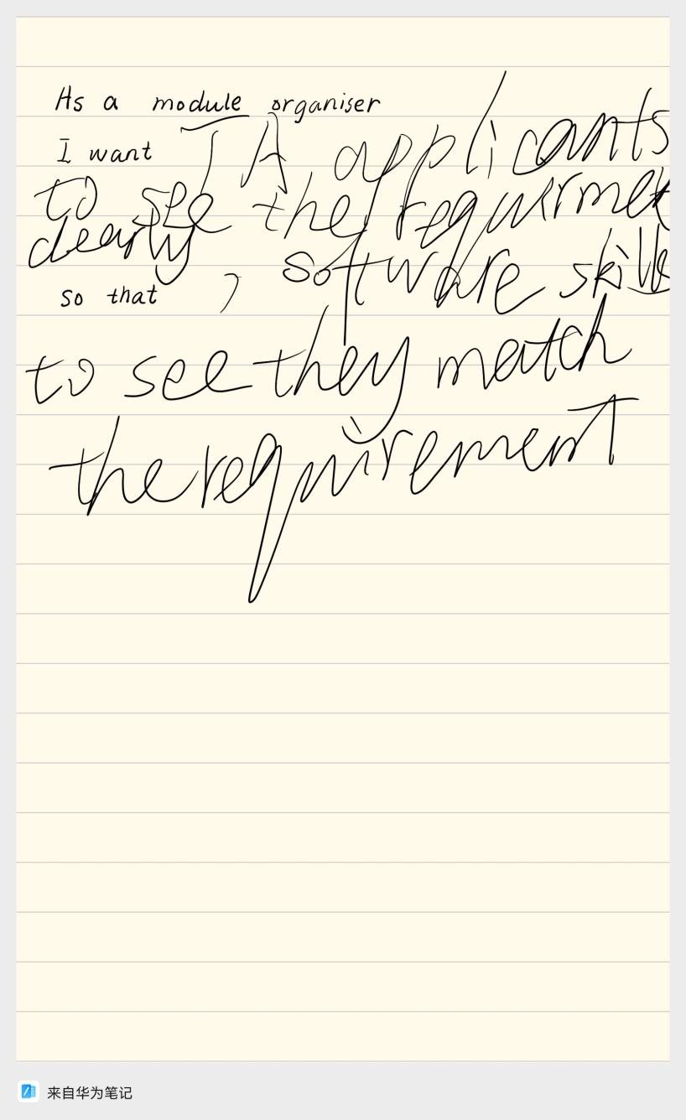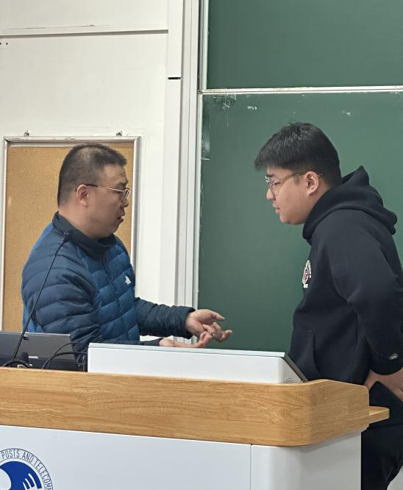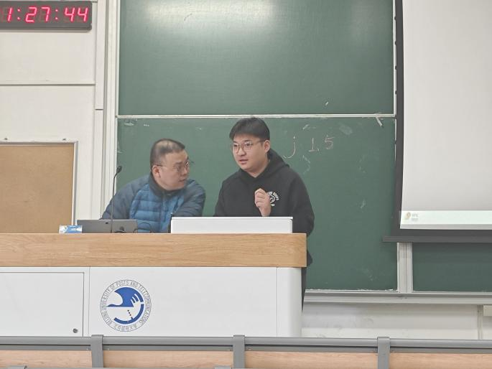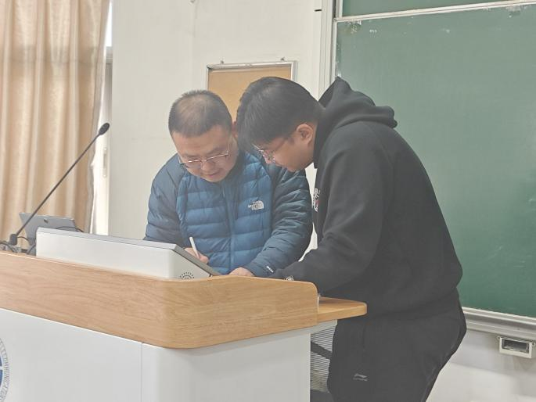

2.1.2 Interview with Jonathan Loo, Teacher of Microprocessor Systems Design（2026/3/19）
The user stories mentioned by Dr.Jonathan have been included in the .xlsx file of the submitted folder.
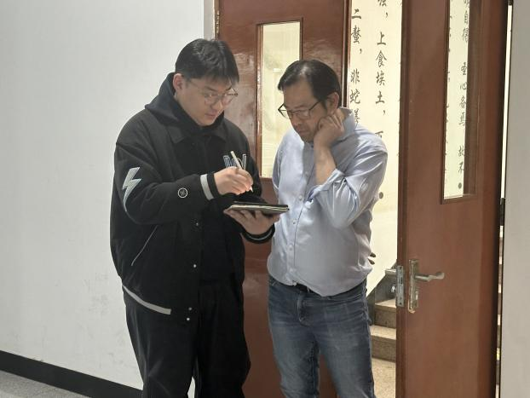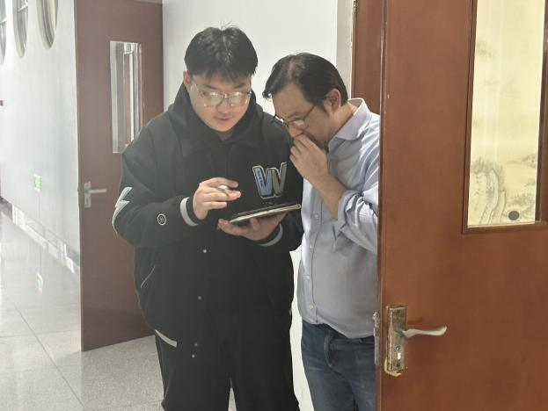
Q:Hello, sir. It's like this.
A:说中文就行。

Q:是这样的，老师，我们软件工程的小项目是要做一个TA招聘系统，您作为Module Oragniser，想听听您对于这个系统有没有什么建议？
A:现在就要说吗？
Q:是的老师，只需要在pad上写一下I want什么功能，以便于可以如何如何。
A:对于这个，我还真是有很多想说，明天早上Coding Day的时候我给你答复吧。
Q：好的，谢谢老师。